Fraser Jones
Literature Review

Realizable k-ε Viscosity Model Paper Review

I chose to review “A New k-ε Eddy Viscosity Model for High Reynolds Number Turbulent Flows-Model Development and Validation” by T.-H. Shih, W.W. Liou, A. Shabbir, Z. Yang, and J. Zhu because I have found Realizable k-ε (RKE) modeling to be superior to Standard (SKE) and Renormalized Group (RNG) in RANS simulations of film cooling holes. To gain a better understanding of how RKE differentiates itself from other k-ε models, I reviewed how the model was formulated and compare CFD results from the original authors, NASA, Pope, and my own CFD studies. I discovered that decoupling the production and dissipation of turbulent kinetic energy (TKE), and allowing the coefficient of turbulent viscosity to vary such that realistic physical constraints are not violated makes RKE substantially more accurate than SKE. However, RKE cannot avoid limitations inherent to two-equation turbulence modeling evident when turbulence cannot be considered isotropic.

The Authors begin by deriving the realizable k-ε model and note that the equations for TKE are identical to standard k-ε but the dissipation equation has three significant changes.
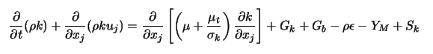

The modeled transport equations for turbulent kinetic energy (k) and dissipation (ε). “G” represents generation. These equations have already assumed the turbulence to be modeled as isotropic.

First, the dissipation production term (second term on the RHS) is now independent of k. This is believed to better model the regions of flow where dissipation is occurring even in the absence of significant turbulent kinetic energy. Second, the denominator of the dissipation destructor term (last term on the RHS) never becomes singular. This prevents a sudden spike in dissipation as TKE tends to zero. The final change is allowing the coefficient of turbulent viscosity to vary based the local flow field. Pope notes (page 108, figure 5.10) normalized turbulent diffusivity is far from a constant and can vary significantly, especially in regions of intermittency.

The “Realizable” name comes from having the variable turbulent viscosity bound by certain physical constraints. Following the same derivation as SKE, the authors model turbulent viscosity with the Boussinesq hypothesis to relate mean velocity gradients to Reynolds stresses and the eddy viscosity model. The “realizable” comes when the Boussinesq and eddy viscosity models are combined and constrained to be realistic.

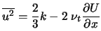

Clearly, if turbulent viscosity is held as a constant, there are cases where the mean shear stress can create negative normal stresses. Similarly, the Schwarz inequality for shear stresses can be violated when the mean strain rate is large enough.

These challenges are addressed by modeling the coefficient of turbulent viscosity as a function of local strain rates.
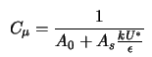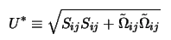
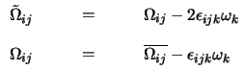
This rather elaborate model comes from viewing the flow within a rotating reference frame with angular velocity ω_{k}.
The constant A_{o} is now the only new, undetermined part of the RKE model and is determined by experimental data from homogenous shear and boundary layer flow.

Likewise, an equation for C₁ is generated which allows for the decoupling of dissipation production from turbulent kinetic energy.
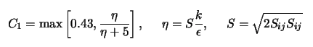
To validate the RKE model, the authors provide a number of tables comparing their data to simulation and experiment. Both RKE and SKE do fairly well at predicting spreading rates for free shear and flat plate flows. Since their coefficients are calibrated from similar experiments that is unsurprising. NASA provides much more interested plots that show the stark difference in performance between SKE and RKE models in rotating homogenous shear flows.

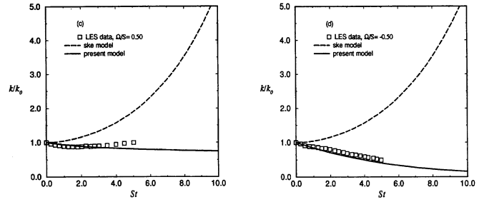

The realizable k-ε model is an enormous improvement for predicting the decay of TKE in rotating homogenous shear flow. However, the authors do mention that the mathematical formulation of RKE tends to break down when multiple rotating reference frames are used in the same simulation.

While RKE improves on many of the weaknesses of SKE, it still suffers when the assumption of isotropic turbulence is a poor estimate of the real flow. In round jet simulations near the centerline, <u²> is the primary Reynolds stress (Pope p.106, Figure 5.7). The turbulence is not isotropic so a k-ε model would be expected to perform poorly at predicting the turbulent field. RKE simply cannot distinguish the individual contributions from <u²>, <v²>, and <w²>.

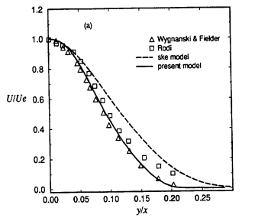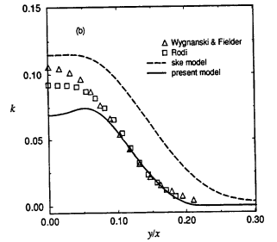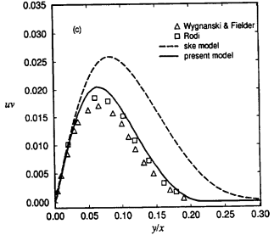

Realizable k-ε underpredicts the TKE near the center of a round jet while standard k-ε overpredicts TKE. RKE still performs better in predicting Reynold shear stresses because of the decoupling of TKE production and dissipation.

A final comparison of standard versus realizable can be created based on test cases from the Langley Research Center Turbulence Modeling Resource (https://turbmodels.larc.nasa.gov/) for flow into a bluff body. I recreated the simulation in Fluent to better show the difference between models. The bluff body is 10mm wide, flow is air at STP and 1 m/s,
Re = 670. Simulation is coupled solver with 3rd order accurate modeling. Grid independence was verified at 400% grid resolution returning identical results for both SKE and RKE. Standard Wall functions were used from y+ = 100 to the wall.

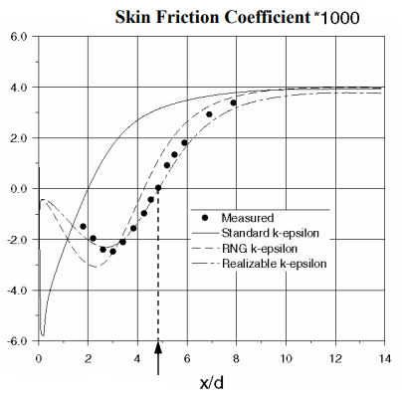
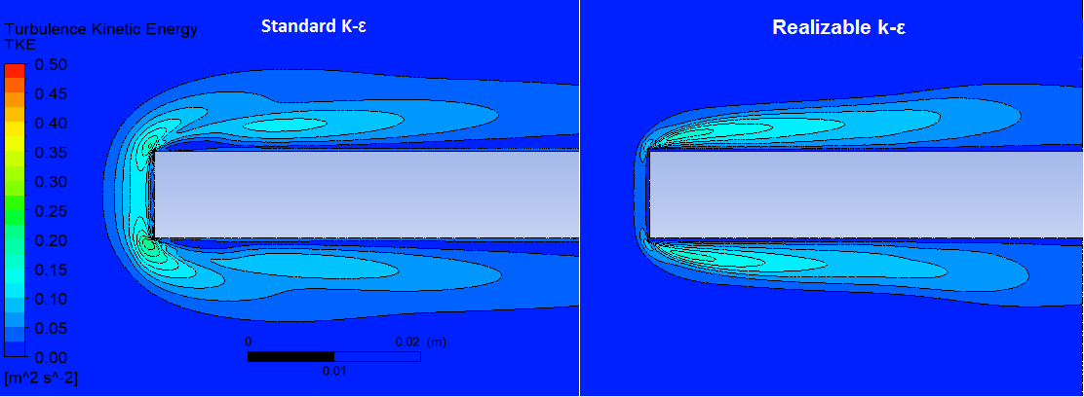
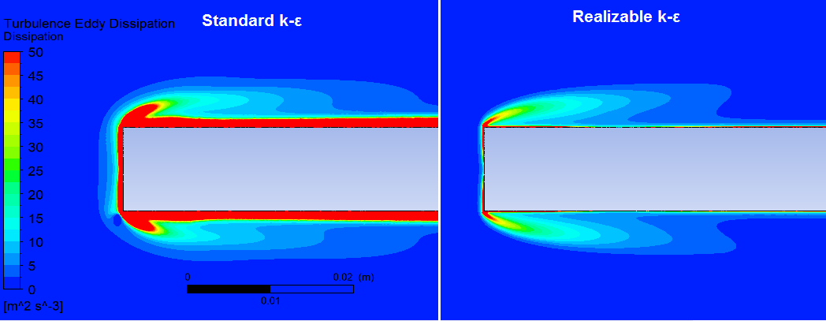
My simulation from Fluent showing significantly different TKE and excessive dissipation in SKE. Data from (https://turbmodels.larc.nasa.gov/) comparing reattachment of separation in flow past a blunt plate. RKE almost exactly predicts the reattachment location and wall shear stress.

This simulation really shows how a sharp bend creates a large mean velocity gradient causing a singularity in the dissipation production term for standard k-ε. Decoupling TKE and dissipation along with bounding the modelling coefficients to be physically realistic dramatically improves performance.

